
NOTE: This is an official document by Indexademics. Unless otherwise stated, this document may not be accredited to individuals or groups other than the club IDX, nor should this document be distributed, sold, or modified for personal use in any way.
IDX G9 Math H STUDY GUIDE ISSUE 7
By Samuel Wu and Grace Yu

Points and Lines
Coordinate Geonetry
- One-to-one correspondence between the set of real numbers and the set of points on the number line. Extending this concept, there is one-to-one correspondence between the set of points on the plane and the set of ordered pairs of real numbers.
- One reference system used to represent this correspondence is called a rectangular, or Cartesian, coordinate system.
- x-axis – one horizontal number line
- y-axis – one vertical number line perpendicular to x-axis.
- Origin – The point of intersection at the zero value on each line.
- Coordinate axes – x- and y axes together
- Quadrants – four parts that are formed by dividing the coordinate plane
with the coordinate axes.
- Each point P in the xy-plane can be assigned a unique ordered pair (x, y).
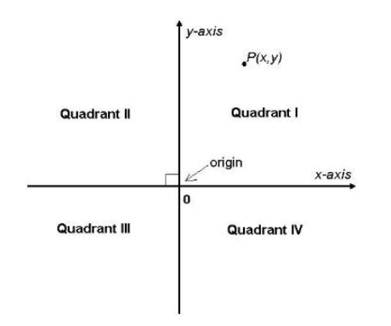

Linear Equations
- Given a set S of ordered pairs of numbers, each element of the set can be represented by a point in the plane. The graph of S is the set of all such points.
- x-intercept – The x-coordinate of the point where the graph of an equation intersects the x-axis.
- y-intercept – The y-coordinate of the point where the graph of an equation intersects the y-axis
- Linear equation Ax+By=C, A B are not both zero: its graph is a line.
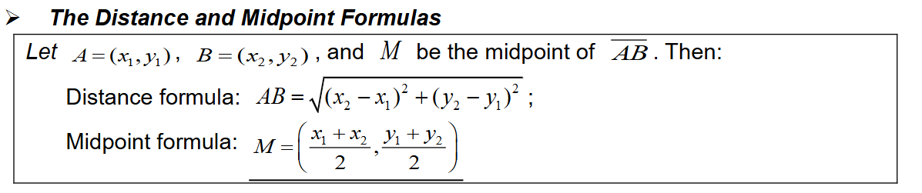
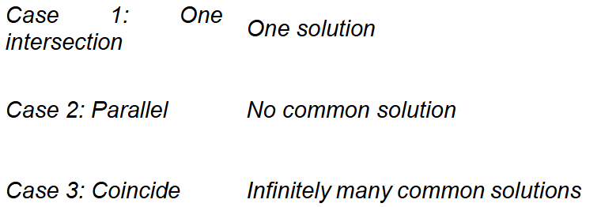
Slopes and Lines
Slope of a line
- The steepness or slope of a nonvertical line is defined as the ratio of the change in the vertical distance (rise) to the change in the horizontal distance (run) between any two points on the line.
- Parallel lines have a slope of same
- Perendicular lines have negative reciprocal slope
Finding Equations of lines
